Bachelor of Architecture – Thesis Manual

- FORMAT

- Thesis should not exceed 100 pages in addition to references
- Thesis may be submitted in English or in Arabic in coordination with the supervisor following the same format.
- Paragraphs should Start with Capital letters (Not numbers or symbols)
- Abbreviations should be fully written when used for the first time, for example "Food and Agriculture Organization (FAO)" then the abbreviation can be used without brackets afterwards.

A.1 Margins
- Page set up (for the entire manuscript including the figures):
o Top: 2.5 cm; Bottom: 2.5 cm
o Right: 2.5 cm; Left: 3.5 cm
- The text must be aligned to the left.

A.2 Spacing
- The text should be written double-spaced.
- Leave one line before starting a new paragraph
- Start each stage/phase on a new page

A.3 Pagination
- Each page of the manuscript must be numbered in the right bottom of each page
- The body of the text and the reference are numbered using Arabic numerals (1, 2, 3, etc.).
- The preliminary pages (Table of contents, Table of figures, Table of tables) are numbered using Roman numerals (i, ii, iii, etc.). No page number is used for the title page.

A.4 Printing
- The thesis must be printed on one side of white A4 paper (In addition to A2 or A3 papers folded to A4 size if needed)
- The presentation may be portrait or landscape
- The print should be clear and easy to read.
- The first and last pages of the manuscript should be blank (no page number).

A.5 Binding
- First semester (unbinded) collected together using paper clips
- Second semester (Final thesis submission). Book binding is required using hard cover (spiral binding is not accepted).

A.6 Soft copy submission
First semester (1 cd taped with the unbinded thesis)
Second semester (1 cd taped with the binded thesis)

A.7 Font type and size (body text)
- Use Times New Roman.
- Headings and titles text size should be 14 pts and bold.
- Text size should be 12 pts, including tables.
- Italics may be used for quotations or words in a foreign language.

A.8 Figures and tables
- Figures and tables should be numbered separately using Arabic numerals based on their order of appearance in the text. Figure 1 and Table 1 are the first figure and the first table in the text.
- Each figure and table should have a title. Figures and tables are written with capital F and T.
-Title of each figure or table should be written under it.
- Figure and table legends should provide enough information to allow their understanding without reference to the text.
- Figures and tables with their legends can be integrated in the text..

A.9 Footnotes
- Place an asterisk ( *) in the text, and write the comment behind the asterisk in the bottom ofthe page. If you need more than one comment on the same page, use two (**), then three (***)
asterisks etc.

- CONTENT

Each section should start on a new page.

B.1 Title Page
University, Faculty, Department (font size = 16 pts - Bold)

Title (14 pts)

Submitted by (name of the student as officially registered at the University) (14 pts)
Supervised by (name of supervisor) (14 pts)

Thesis submitted in partial fulfillment of Graduation Project in Architecture (14 pts)

- See Title Page format

B.2 Table of Contents
Should include all main divisions and subdivisions in your text and corresponding page number. (12 pts)

- See Table of Contents page format

B.3 List of Figures or Illustrations
- List title of figures with page number.
- Use the same format as the Table of Content.

B.4 List of Tables
- List title of tables with page number.
- Use the same format as the Table of Content.

B.5 Core of the text
- Start numbering with Arabic numerals.
- Start each chapter with a new page.
- Further divide each chapter into parts or sections numbered or labeled. Make sure the system you use is consistent through the text. The divisions below provide an explanation of each title.

Introduction
Explaining the context of the study through defining the vision; in addition to the project statement and the various goals and objectives

Chapter 1: Theoretical Background and literature review
A critical review of theories and different thinking approaches in addition to research papers relevant to the project.

Chapter 2: Site analysis
At least three sites are proposed and evaluated using site selection criteria through which the project site is determined and fully analyzed as follows:
- Environmental analysis
- Physical analysis
- Psychological analysis

Chapter 3: Precedents analysis
At least three architectural case studies of similar projects, in addition to any compatible case studies or examples that shouldn’t necessarily be architectural.

Chapter 4: Pragmatic thinking approach
- Pragmatic thinking process: diagrams, spatial arrangements and whatever pragmatic thinking process may include.
- Program: tables of spaces (areas in square meter) of different functions, bubble diagrams, connectivity diagrams, etc.

Chapter 5: Conceptual Approach and Design
- Concept statement and conceptual diagrams
- Diagrams that explain form evolution

Chapter 6: Final Design
- Site plan, plans, sections and elevations with the scale shown on each sheet
(North sign should be clear on site plan and plans, clear dimensions on plans)

Chapter 7: 3 Dimensional illustrations and Perspectives

B.6 References:

Use APA referencing as follows:

- In-text referencing:

APA is an 'author/date' system, so your in-text reference for all formats (book, journal article, web document) consists of the author(s) surname and year of publication.
The basics of an in-text reference in APA:
- Include author or authors and year of publication.
- Use round brackets.
Example: (Smith & Bruce, 2018)
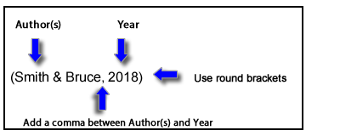
If you quote directly from an author you need to include the page or paragraph number of the quote in your in-text reference. See the 'Quotes' section below for more advice on adding quotes into your work.
- Include author or authors, year of publication and page or paragraph number of your quote.
- Use round brackets.
Example: (Smith & Bruce, 2018, pp. 25-26)
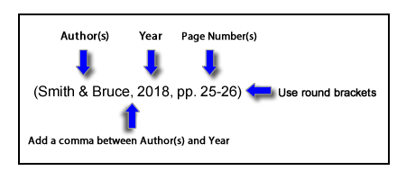

- The reference list:

All in-text references should be listed in the reference list at the end of your document. The purpose of the reference list entry is to contain all the information that a reader of your work needs to follow-up on your sources. An important principle in referencing is to be consistent.
When compiling your APA Reference List, you should:
- List references on a new page with a centred heading titled: References.
- Include all your references, regardless of format, e.g. books, journal articles, online sources, in one alphabetical listing from A - Z.
- Order entries alphabetically by surname of author(s).
- List works with no author under the first significant word of the title.
- Indent second and subsequent lines of each entry (5-7 spaces).
- Use double spacing.
- Note that all references in APA end with a full stop except when the reference ends with a URL or a doi.
- Citing a Journal article
A basic reference list entry for a journal article in APA must include:
- Author or authors. The surname is followed by first initials.
- Year of publication of the article (in round brackets).
- Article title.
- Journal title (in italics).
- Volume of journal (in italics).
- Issue of journal (no italics).
- Page range of article.
- DOI.
- The first line of each citation is left adjusted. Every subsequent line is indented 5-7 spaces.
Example: Ruxton, C. (2016). Tea: Hydration and other health benefits. Primary Health Care, 26(8),
34-42. doi:10.7748/phc.2016.e1162
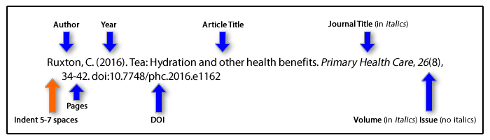
- Citing a Book
A basic reference list entry for a book (print version) in APA must include:
- Author or authors. The surname is followed by first initials.
- Year of publication of the book (in round brackets).
- Book title (in italics).
- Edition (in round brackets), if other than first edition.
- Place of publication.
- Publisher.
- The first line of each citation is left adjusted. Every subsequent line is indented 5-7 spaces.
Example: Arnott, G. D. (2017). The disability support worker (2nd ed.). South Melbourne, VIC: Cengage Learning.
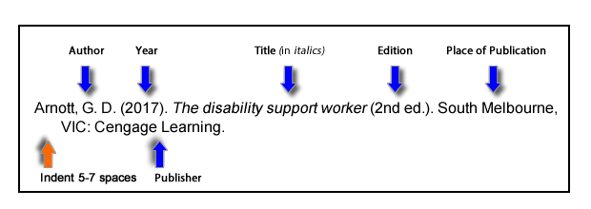
- Citing an unpublished thesis
The basics of a reference list entry for an unpublished thesis:
- Author. The surname is followed by first initials.
- Year (in round brackets).
- Title.
- Level of Thesis (in round brackets).
- University.
- City.
- Country.
- The first line of each citation is left adjusted. Every subsequent line is indented 5-7 spaces.
Example:​
Zarei, R. (2017). Developing enhanced classification methods for ECG and EEG signals (Unpublished doctoral dissertation). Victoria University, Melbourne, Australia.
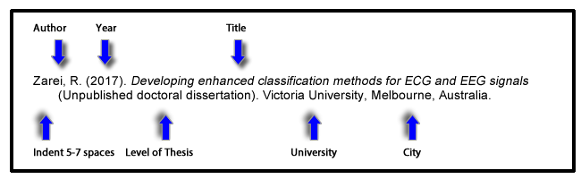
Please note:
- A thesis can come in a number of formats, i.e. they can be published, unpublished or retrieved from a database.
- The principles when referencing a thesis are similar to those employed when referencing a book.
- The example above is for an unpublished thesis, examples for an online or a published thesis can be found below.

- Quotes in APA

For direct quotes of less than 40 words, incorporate them into the text and enclose the quote with double quotation marks, e.g.
Webber (2018, p. 82) concludes that “addressing the issue of school dropout not only affects the education system, but may also serve as a prevention effort for the welfare, mental health, and corrections systems”.
For direct quotes of 40 or more words start a new paragraph that is indented from the left. The entire quote should be double-spaced. Quotation marks are not required e.g.:
Others have contradicted this view, suggesting:
These overload issues can reach across the lifespan and affect individuals in many ways. As related issues continue to emerge, counselors will need to be aware of potential mental health problems stemming from technology overload and continue to research and develop the skills needed for effective interventions. In the digital age, these capabilities will be crucial in helping clients regain and maintain a healthy balance of life, work, and technology. (Scott, Valley & Simecka, 2017, p. 605)
Note: Use paragraph numbers if no page numbers are available.

- Citing tables and figures:
- Tables are numerical values or text displayed in rows and columns.
- Figures include graphs, charts, maps, drawings and photographs.
When including tables or figures in your work, please note:
- All tables and figures must be referred to in the main body of the text.
- Number all tables and figures in the order they first appear in the text.
- Refer to them in the text by their number. For example:
As shown in Table 2...
OR
As illustrated in Figure 3...
- Each table or figure should be accompanied by a concise description of the contents, presented directly below the figure.
- When reproducing a table or figure from another source you must also include a citation with the caption, as well as in the Reference list. You may need to obtain written permission from the copyright holder. The copyright permission statement should be included at the end of the caption.
- Note that you should use the wording "Reprinted [or Adapted] with permission" only when permission has been sought and granted.
Examples:
1. If you reproduce a figure, credit the original source in full at the bottom of the reproduction. Cite the source in full in your reference list:
Figure 1. A credibility judgment is arrived at within the larger context of one's background, prior knowledge, assumptions and biases, as one performs a series of iterative assessments based on one's defined need, specific attributes of the source and rules of thumb that have worked successfully in the past. From "Evaluation techniques," by D. Cunningham, 2008, Annals of Psychiatry, 36, p. 35. Copyright 2008 by David Cunningham. Reprinted with permission.
Reference List
Cunningham, D. (2008). Evaluation techniques. Annals of Psychiatry, 36(2), 24-45.
2. If you adapt a figure, credit the original source in full at the bottom of the figure but add the words 'Adapted from' to indicate it has been changed by you, and cite the source in full in your reference list:
Figure 1. A credibility judgment is arrived at within the larger context of one's background, prior knowledge, assumptions and biases, as one makes interim decisions based on one's defined need, specific attributes of the source and rules of thumb that have worked successfully in the past. Adapted from "Evaluation techniques," by D. Cunningham, 2008, Annals of Psychiatry 36, p. 35. Copyright 2008 by David Cunningham. Adapted with permission.
Reference List
Cunningham, D. (2008). Evaluation techniques. Annals of Psychiatry, 36(2), 24-45.
3. Follow a discussion of a figure viewed in another source (but not reproduced) with an in-text citation for the published source. Include the figure number as it appears in the published source. Cite the source in full in your reference list:
... evaluating the credibility of a source is shown as the interaction between one's defined need, specific attributes of the source, and rules of thumb which have worked previously when evaluating sources (Cunningham, 2008, p. 35, fig. 3).
Reference List
Cunningham, D. (2008). Evaluation techniques. Annals of Psychiatry, 36(2), 24-45.

- Citing a YouTube Video:
The general format is as follows:
Author, A. A. [Screen name]. (year, month day). Title of video
[Video file]. Retrieved from http://xxxxx
For retrievability, the person who posted the video is put in the author position. You might have noticed that the template shows both a typically formatted author name and a place for a screen name, and here's why: On YouTube and many other video-posting websites, users must post under a screen name. This screen name is integral to finding the video on YouTube, so including it in the reference is important. Sometimes, however, the real name of the individual who posted the video is also known. The individual's real name likely better connects him or her to the real world as well as to any other sources he or she may have provided for your paper (e.g., an author who wrote an article and also produced a YouTube video). Providing the real name, when available, aids the reader by highlighting these interconnections and also makes it possible to alphabetize the reference among any other references by that same author in the reference list. Thus, the reference format for a YouTube video includes both elements when both elements are available.
Example:
Apsolon, M. [markapsolon]. (2011, September 9). Real ghost girl
caught on Video Tape 14 [Video file]. Retrieved from
http://www.youtube.com/watch?v=6nyGCbxD848
(The capitalization [or lack thereof] in the screen name is in keeping with how it appears online.)
On YouTube, the screen name is most prominent. If the user’s real name is not available, include only the screen name, without brackets:
Screen name. (year, month day). Title of video [Video file]. Retrieved
from http://xxxxx

Example:
Bellofolletti. (2009, April 8). Ghost caught on surveillance camera
[Video file]. Retrieved from http://www.youtube.com/watch?v
=Dq1ms2JhYBI&feature=related
In text, cite by the author name that appears outside of brackets, whichever one that may be. For example, the two example references provided above would be cited as follows: (Apsolon, 2011; Bellofolletti, 2009)

- Citing interviews
The citation of interviews depends on the nature of the interview.
Third-party interviews: If the interview is in a form that is recoverable (e.g., a recording, transcript, published Q&A), use the reference format appropriate for the source in which the interview is available.
Informational interviews: If you have interviewed someone for information about your topic and that person has agreed to be identified as a source, cite the source as a personal communication (in text only).
Example:
(G. Fink-Nottle, personal communication, April 5, 2011)
Personal communications do not have reference list entries because they cannot be retrieved.
Interviews of research participants: No citation is needed for remarks made by participants in the research on which you’re reporting. Do not cite these as personal communications; this would breach the participants’ guarantee of confidentiality.

- Citing a website

Structure:
Last, F. M. (Year, Month Date Published). Article title. Retrieved from URL

Example:
Satalkar, B. (2010, July 15). Water aerobics. Retrieved from http://www.buzzle.com
Cain, K. (2012, June 29). The Negative effects of Facebook on communication. Social Media Today RSS. Retrieved from http://socialmediatoday.com

- Citing a blog

Structure:
Last, F. M. (Year Month Date Published). Article title [Type of blog post]. Retrieved from URL.

Example:
Schonfeld, E. (2010, May 3). Google throws $38.8 million to the wind [Web log post]. Retrieved May 4, 2010, from http://techcrunch.com
China, The American Press, and the State Department [Web log post]. (2013, January 3). Retrieved from Schonfeld, E. (2010, May 3). Google throws $38.8 million to the wind [Web log post]. Retrieved May 4, 2010, from http://techcrunch.com

University of Jordan,
Faculty of Engineering
Department of Architecture

Title: _________________________________

Submitted by _________________________________________________
Supervised by _________________________________________________

Thesis submitted in partial fulfillment of the requirements of final graduation project in Architecture

Academic Year ___________________________

2. Table of Contents

Page | Subject
i  ii  iii  iv  _  _  _  _  _  _  _  _ | Table of Contents……………………………………………………....….............  List of Tables ……………….………………………………………….………….  List of Figures …………………………….………………..……………………..  Introduction ………………………………………………………………………  Chapter 1 Theoretical Background and literature review………………………  Chapter 2 Site selection criteria and site analysis ……………………….….….  Chapter 3 Case studies ……………………………………………….………….  Chapter 4 Pragmatic thinking Approach………….………………………….……  Chapter 5 Conceptual Approach and Design………………………………………  Chapter 6 Final Design……….……………………………………………………  Chapter 7 3 Dimensional illustrations and Perspectives………………………….  References……………………………………………………………………………

